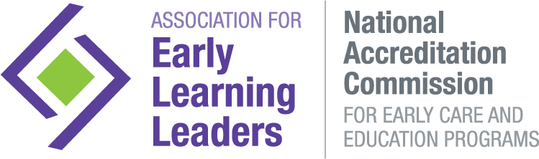
Director Change Submission Form (required for Currently Awarded Programs Only)
To be completed by New Director
Program Name (include corporate center # if Applicable):
Address:
City: |  | State: |  |  | Zip:
Phone: |  | E-mail:
Award expires (full date): |  | Copyright year of manual*
*If unable to locate the National Accreditation Commission manual, call the office at 512-316-3679 to order a new copy.
 | New Director: |  |  | Hire date at this program:
 | Hire date as Director at this program: |  |  | If applicable, hire date with organization:
 | Previous Director: |  |  | Prev. Director Hire Date: |  | Departure date:
 | # of Teaching Staff: |  | # of Teaching Staff hired in the last 4 months:
SUBMIT ALL OF THE FOLLOWING:
This completed Submission Form
$100 Director Change fee
$50 late fee, if paperwork is not submitted within required notification timeframe
Last two Child Care Licensing reports
Note all that apply
Level of Education (HS, GED, some formal Education):
Area of study, if applicable: |  | Number of college hours in CD/ECE:
Copy of National CDA certificate |  | Expiration:
Copy of State Child Development Credential/Certificate |  | Expiration: | Non-expiring
Other Credential/Certificate (for instance, Montessori Certification):
Currently enrolled in college coursework |  | Expected completion date:
Area of study: |  | Number of college hours in CD/ECE:
Currently enrolled in CDA program | Expected completion date:

EDUCATION/EXPERIENCE IN PROGRAM ADMINISTRATION
Number of College Credits in Business Administration /Program Management:
Number of CEUs in Business Administration/Program Management:
Do you have a current National or State Director’s Credential?
Yes (If yes submit a copy of the credential) No
Years in a Supervisory Role (Assistant Director, Program Coordinator, Curriculum Specialist):
Years as a Director, excluding this location:

EXPERIENCE IN EARLY CARE AND EDUCATION
Years in the Child Development field:
Years as a Classroom Teacher:

EXPERIENCE WITH ACCREDITATION (check all that apply):
Director at another National Accreditation Commission Awarded Program
Assistant Director at another National Accreditation Commission Awarded Program
Assistant Director at current program Dates (mo/yr to mo/yr):
Teacher at this or another National Accreditation Commission Awarded Program
Other (note experience with Quality Rating Systems or other Accreditations):
None

KNOWLEDGE OF ACCREDITATION PROCESS AND ACCREDITATION STANDARDS
What is the next step for the program in the accreditation process?
What steps are being taken to become familiar with the Accreditation Manual?

What steps have been taken to ensure compliance with Accreditation Standards?

To submit your Director Change paperwork:
E-mail as 1 PDF attachment to submissions@earlylearningleaders.org. Other file types, including Zip or Drive Share, will not be accepted.

Online payments, including credit card and ACH, can be made at www.earlylearningleaders.org on the Accreditation Fees page.

The National Accreditation Commission counts on the person responsible for the day-to-day operation of the program to maintain overall compliance with Standards, as well as implement and oversee program-wide policies and procedures. All program staff should be familiar with the Standards and the steps required for compliance. Staff training and changes to procedures should be structured to maintain compliance and to seek resolution to any concerns. Observations of staff using the Classroom Observation tool should be conducted regularly. After review of the director change documentation, all directors are required to attend the National Accreditation Commission New Director webinar that focuses on the Accreditation Process. A letter will be e-mailed to the program detailing the attendance timeline and the process for enrolling.

