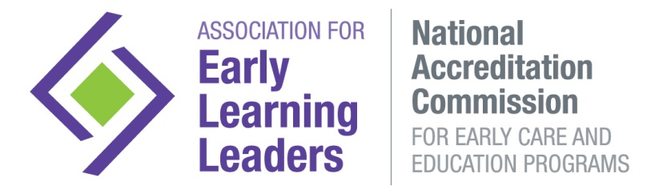
Initial Notification Form
Submit to ensure that there is no lapse in the Accreditation Award
It is very important to immediately notify the National Accreditation Commission of changes to the program. To begin the process for maintaining compliance during program changes, this Initial Notification form is the first step to be completed.
Failure to notify the Commission of program changes will result in the following consequences:
- After the required initial notification period but prior to 45 days: $50 late fee
- 45 days after the required notification period but prior to 90 days: $250 citation fee
- 90 days after the required notification period: Accreditation Suspension

The notification process consists of the following steps.
Step 1: Complete and submit this Initial Notification Form
Step 2: The National Accreditation Commission will respond to the notification, if further inquiry is needed.
Required documentation and the submission form specific to the program’s situation may be requested.
Step 3: Submit documentation as requested by the Accreditation Office by the given deadline.
Step 4: The National Accreditation Commission will give a final response to your specific situation.
*Note: Some program changes may require a validation visit.

Program Name (include program number if applicable):
Address:
City: |  |  | State: |  |  | Zip:
Phone: |  | E-mail:
Name of Contact: |  |  |  |  | Title:
Today’s Date: | Award Date: |  |  | Award Expiration Date:

Check all that apply:
Notification Required within 72 Hours
Licensing violation, licensing noncompliance, or licensing investigation in the areas of child injury, safety, supervision, or guidance
Loss or suspension of license or issued a provisionary license
Criminal conviction of any employee, volunteer or administrator
Loss or suspension of QRIS, tiered reimbursement, or other state recognition status
Decision to discontinue accreditation with the National Accreditation Commission
Notification Required within 10 business days
Director Separation (program should notify that director has left even if replacement is not determined)
Hiring/Appointment of a New Director
Change to child care operating license (Examples: increase or decrease in licensed capacity, addition or removal of operating restrictions)
Any significant event or change that affects program operations and/or Accreditation Compliance (Examples: damage, building construction or repairs, hazardous conditions)
Change in classroom groupings (addition of a previously unserved age group, addition of two or more classrooms, or combining of previously unserved age group with an existing group)
Notification Required Prior to Implementation/Execution Expected Implementation Date
Ownership change
Expansion of facilities, including the playground
Relocation of program
Combining of programs
Closure of a program
Program name change

Other
If Other, please explain:

Date of Incident or Change:
Brief Summary of Incident or Change:

Steps the Program is taking to maintain compliance with National Accreditation Commission Standards:

To submit your Initial Notification Form:
Email as 1 complete PDF to submissions@earlylearningleaders.org

This Initial Notification Form serves as the first step in notifying the National Accreditation Commission of important changes within the program. Remaining steps are detailed on the previous page. The form meets the requirement of notifying the Accreditation Office, as long as the notification is provided within the stated time limits. Typically, any program changes will necessitate submission of further documentation. Requirements will be provided by email using the email provided on this form.

